INTRODUCTION
If you’re reading this, congrats! You’ve downloaded a file from the internet, opened it up, and decided to actually read the documentation for it! Or, at least, this first paragraph from it. I don’t actually know how much patience you have for reading things, so you might have just skipped past this entirely, which is okay.

This is the comprehensive Readme for the Mood Posing Tool (MPT), a new posing system that can give you a lot more ease, versatility, and - most importantly - speed in your posing for Doki Doki Literature Club. Using this tool will require upgrading your mod to use a newer version of Renpy than the current release of DDLC was created in. Refer to Section 1 for more details.

This readme covers a lot, and what you either want or need to look at will depend on just how deep you want to go with the tool. Click on any of the headers to jump to that section, or use the outline sidebar to do the same:

TABLE OF CONTENTS

- SECTION 1 - UPGRADING RENPY:
  - No matter how in-depth you plan to go, if you wish to use the MPT for your own DDLC mod you will need to follow the instructions in section 1, which goes over upgrading to a (required) newer version of Renpy, as well as how to create a mod with the new features that still follows TS’s IP guidelines. This tool will not work with the version of Renpy that the current release of DDLC was created in, Renpy 6.99.12.4; you are required to upgrade to at least Renpy 7.0 to be able to experiment, develop, and create a functioning mod that utilizes the features this tool requires to run. This tool was specifically developed with Renpy 7.3.2, and has not been tested with versions prior to this; it’s recommended to upgrade to at least 7.3.2 to ensure that it works without issue.
- SECTION 2 - USAGE GUIDE AND EXAMPLES:
  - Section 2 explains how the MPT works for you on just a plain scripting level - as in, how to use it in your Renpy scripts, and teaches the most important concepts behind what the tool is capable of, and what advantages it has over alternate posing systems. If you don’t care about any of the more in-depth coding stuff or how the tool ultimately works on the programming level, then read this section and then look at the cheat sheets and charts in section 3 - you’ll learn enough to be off and running with the tool in your script.
- SECTION 3 - CHEAT SHEETS AND CHARTS:
  - If you’ve either read section 2 or don’t want/need to go through a long explanation about how to use the MPT, then just head here; it contains all the quick-to-read charts detailing what’s possible with the tool.
- SECTION 4 - PROGRAMMING, LOGIC, AND ADDING YOUR OWN ASSETS:
  - Section 4 is the more in-depth documentation about how exactly the MPT works and provides the functionality that makes it quicker/easier to pose your characters. It also contains instructions on how to add in your own custom assets for use with the tool.
- SECTION 5 - ROADMAP:
  - Section 5 briefly goes over some of the future updates I wish to make to the system, but will not be included in the initial release of the tool.
- SECTION 6 - ADDITIONAL LINKS:
  - Further information can be found at the links listed here.
- SECTION 7 - CREDITS AND THANKS:
  - I definitely didn’t put this all together myself, and I’m appreciative of all the help people have given me in getting this up and running.

SECTION 1 - UPGRADING RENPY
(Click me to return to the table of contents)

Downloading and installing Renpy:

This is actually fairly straightforward - simply go grab the latest version from the official website: https://www.renpy.org/latest.html

The MPT was developed in 7.3.2, and has been tested with the most recent Renpy release as of this writing (7.3.5). Theoretically, earlier versions of Renpy 7.x would work as well, but this is untested and thus we can’t guarantee it’ll work.

Luckily for DDLC modding, DDLC was developed in Renpy 6.99.12.4 - which was one of the last versions released before Renpy 7 was released. This is relevant to bring up, since it means that upgrading your project to Renpy 7 is likely to generate few - if any - errors that are caused by the change in base code. Keep in mind that this is a very general statement - your mileage may vary.

In any event, developing with a newer version of Renpy is identical to developing with the older version; add your project to Renpy 7 in whichever manner you did so with 6.99.12.4, and you should be off and rolling.

Adding the MPT files to your project:

This part’s pretty easy once you’ve upgraded to Renpy 7. Just do the following:

- Either navigate to your project’s “/game/mod_assets/” directory, or create said directory.
- Open up the archive you’ve downloaded (You’ll want to use the “unpacked” version for your in-development projects, found here: https://drive.google.com/open?id=136KBThnImX3qABRlMO8YKykM5gtLI_6x ) and drop/extract the “MPT” folder from said archive into the “/game/mod_assets/” directory of your project - if you’ve done it right, you should end up with a new subdirectory - “/game/mod_assets/MPT/”, which has further files within itself.
- That’s it! If you’ve done it correctly, you should now have access to all of the MPT sprites and their tagging and keywords.

These files are compatible with any other poses and definitions you may have, so long as they don’t somehow overlap with names/tags. This means that they’re fully compatible with all of the base game’s poses, as well as all of the poses generated by AgentGold’s pose tool.

Building and Distributing a Finished Mod/Project:

This actually isn’t too difficult of a process, but it is of vital importance to stress how important this is for distributing a mod that both follows TS IP and also works. You will need to follow the below instructions now that you’re working in a newer version of Renpy than DDLC was created in:

- Create your .rpyc/.rpa files as normal. Make sure you’re compiling your mod in Renpy 7, and not in any older versions of the renpy SDK. This will create your compiled mod’s archive as normal.
- Inside the archive, you’ll see your mod’s files as usual (Mostly in the “game” folder), along with two other important folders - “renpy” and “lib”. These are important, do not remove them from your archive; they are what actually contain the 7.3.5 engine files, and make using this tool possible in an existing DDLC install.
- When installing the mod, copy the files - including those “renpy” and “lib” folders - into the DDLC base directory, so that the renpy and lib folders that come with DDLC are overwritten.
- Start the game like normal.

On request from Team Salvato themselves, we’d also like to add the following note:

Please do not use this method to upgrade an original download of DDLC to Renpy 7 (i.e., without modification other than the engine upgrade) and then distribute that copy in lieu of following these steps; the copy of DDLC you are working from (or anyone playing your mod are using) must still originate from TS themselves for your work to follow TS IPG.

This guide isn’t intended to give instructions on how to violate IPG; the players of your mod must still be using a clean install directly from one of TS’s sources themselves, such as from https://ddlc.moe/ , and thus these instructions are here to allow your players to install the mod in roughly the same manner as with a non-renpy 7 mod - as a package of files that can be dropped into a clean install.

SECTION 2 - USAGE GUIDE AND EXAMPLES
(Click me to return to the table of contents)

2A - General Usage Flow and Demonstration:
So, the idea behind the MPT is twofold:

- Being able to have a very robust/versatile posing tag system that allows for quick and intuitive tagging of poses, without slowing the user down beyond the initial learning curve.
- Being able to quickly change between moods and expressions without too much concern for what exact pose or expression you need to go to for most tasks, but leaving the ability to specify a particular expression at any time for when you need the exact right expression for that important emotional moment.

So, with that in mind, this section will primarily go over how to use it in your project, without delving into the programming and logic details too heavily and just using the base logic (Refer to Section 4 if you’re interested in learning more about that).

If you’re using this, it’s likely that you’re coming from using one of two different main types of posing styles - either the base game’s poses (“show sayori 1a at t11”), or possibly also AgentGold’s posing tool (“show monika u122111 at t11”). This is a massive oversimplification, but the important thing to note is that in both of those cases, you’re fundamentally doing this:

- Indicating which character you’re referring to (Either with “show [CHARACTER] [tag]” or in-line with a line of text from the character like “[CHARACTER ABBREVIATION] [tag] “[dialogue]” “).
- Indicating which pose/expression they’re showing (“show monika [TAG]” or “m [TAG] “dialogue”), by exactly typing in a specific tag.

This tool doesn’t change anything about the first part of that - you’re still doing “show monika” or “m [dialogue]” the whole time with this. What’s different is the second part of that - the tags.

If you’re using the base posing system, then you’re basically restricted to the relatively small set of premade expressions for the game, and/or have expanded upon them with more premade expressions...and have to go make a new definition every time you need a new expression to use, which ultimately results in a single tag again. You also have to do this with the arbitrary set of pose tags that are completely undescriptive and not particularly intuitive, meaning you have to either memorize an entirely different list for each character...or you have to have a cheatsheet out constantly due to said lack of description.

If you’re using AgentGold’s posing tool, you have a lot more versatility, which is good...at the expense of having to learn and memorize an even less intuitive tagging system. Further, to generate the poses you want to use, you then have to separately run a perl script to scan all your files, see what tags you’ve used, and then generate the definitions for you in a separate file. This isn’t too big of a problem if you don’t do this often, but if you need to check on poses or tweaks often enough, it starts to become slower and slower to have to repeatedly remake the files just to see what the poses actually look like. If you need to see *one* new expression, you need to run through the script...and then if it turns out that it wasn’t right and you need to tweak it, you then need to run it *again*...and as many times as you need to, until you have the right expression in place. This is known as “a huge time sink”.

With the MPT, all of these cons are accounted for:

- All the tags have relatively straightforward and intuitive names, which are easy to comprehend and remember without having to resort to rote memorization.
- There are also intentionally short tags that you can use as well, if you’re okay with learning shortened tag names to speed along typing/inputting your poses.
- Since they’re built with a feature that’s native to renpy - layeredimage, which is specifically designed to bypass having to create individual definitions for *each* image you wish to use - there is no need to either hand make a new definition or run an external program to do it for you; it just works on the fly, no further coding necessary.

So, how do you use this? Well, here’s the big thing to remember - you’re going from one single tag to a multiple part tag that tells renpy what to show on the character. So, instead of either:

“show yuri 1a at t11”

Or

“show natsuki u213114 at t11”

You’re instead doing something like this:

“show sayori turned rup lup happ om e2a awkw at t11”

So, I just went on a tangent saying how much quicker this MPT thing is, and then threw that really long series of tags at you - what gives, right? I thought this thing was supposed to be quicker and easier! Well, it still is, for a lot of reasons - and to really demonstrate the strength of this thing, let’s take a base pose from DDLC and look at how we could show it. One important thing to keep in mind is that the idea behind the MPT is that it’s intended to work around how posing is really done - which is less to do with how quickly one specific image is brought up on screen, and more to do with how quickly you are able to switch and flow between multiple images over the course of your script. This is where the advantages of the MPT really become obvious.

For this first example, we’ll take a base pose that’s available in DDLC and replicate it when possible in both the posetool and the MPT - and in the interests of being fair, this particular expression happens to have a mood tag that covers a lot of the required things going on. Anyway, here’s what we’re comparing - we’re going to assume that sayori isn’t anywhere on screen yet, and thus have to freshly introduce the character to the screen. This way, the older systems have as much of a chance as possible:

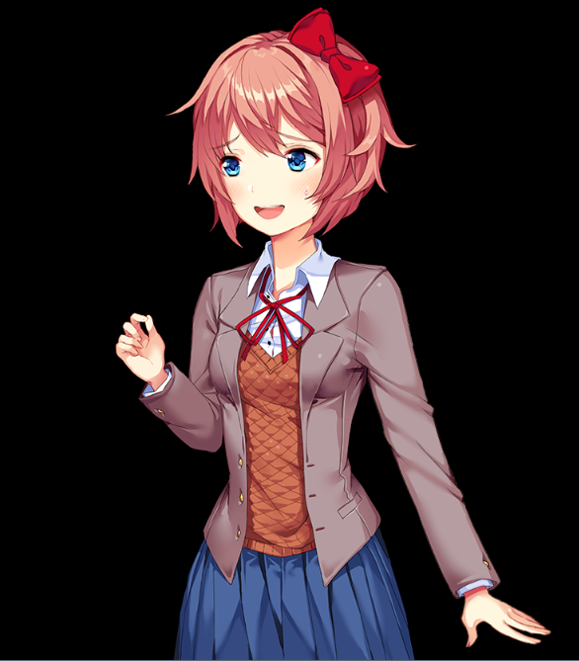 | Base DDLC:  “show sayori 3l”
Posetool:
“show sayori u212222”
(Make sure to run the perl script after putting the tag in your script.)
layeredimage:
“show sayori turned lup nerv om e1b awkw”

So far, it’s not looking all that great for the layeredimage system - that’s a whole lotta tags for this particular premade pose, though I’d still argue that every tag for the MPT is more intuitive than either of the old systems. Here’s a quick breakdown of those tags, for the record:

- “turned” is the overall pose for Sayori; it basically denotes that it’s this ¾ view that is her “normal” pose in the game, and not an alternate pose like her “finger tapping” pose.
- “nerv” is the mood in use for this pose. This is important, but we’ll come back to what it’s actually doing later. For now, just keep in mind that this tag is present on her.
- “lup” means “left arm up” - or, rather, her right arm, since that’s her right arm but it’s the left arm that we see on screen.
- “om” means that her mouth is open. This is an automatic tag - we’ll get to what that means later.
- “e1b” is that specific set of eyes - “large pupils, looking to her right”. This is a specific tag, which means that only those eyes will ever be shown while the tag is in effect.
- “awkw” is her nose area - it’s the “awkward sweat drop” there.

Now that the character’s been shown on screen, this is where the real strength of the MPT and moods come into play. Our hypothetical script now has Sayori on screen, and now she’s going to be changing pose a bit as she talks and emotes through the script. First, lets have her drop her arm down:

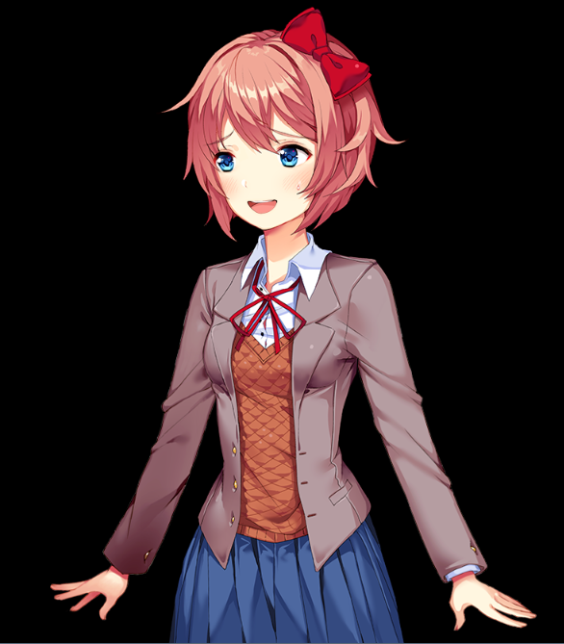 | Base DDLC:  “show sayori 1l”
Posetool:
“show sayori u112222”
(Make sure to run the perl script after putting the tag in your script.)
layeredimage:
“show sayori ldown”

Aha - here’s where we see our first big change with the MPT: notice that all we said here was “ldown” - to put the arm down, and nothing else. Because of how the MPT splits the tags of the images apart, it’s able to take changes to one part of the sprite, and retain the changes to the other parts; for both of the previous systems (and especially the pose tool) every tag you give them must include every part of the pose, even if all you want to change is one part of it. This doesn’t seem that bad with the base DDLC poses yet, since all we’ve done is changed an arm, but for the pose tool this means a lot of either copy/pasting or hoping you correctly put the entire pose back in exactly the same except for the one thing you want to show differently - which, again, isn’t helped by how much less intuitive the tagging system is for the pose tool (We’ll talk about that specific problem a bit more later). Anyway, in our hypothetical scene, sayori now wants to close her mouth with a smile, but (again) change nothing else:

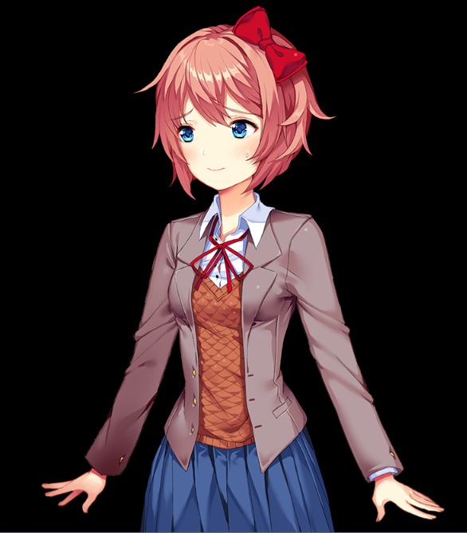 | Base DDLC:  This image doesn’t exist in base DDLC. Time to open up your art editing program of choice, edit a new version of the sprite, and then write a new definition! That, or just be satisfied with “1y,” since that’s the closest pose to this one, but changes the sweat drop for a blush too.
Posetool:
“show sayori u111222”
(Make sure to run the perl script after putting the tag in your script.)
layeredimage:
“show sayori cm”

This is the point at which the base DDLC poses immediately fall apart, and either the pose tool or the MPT becomes the obvious winner. It’s the usual thing for the posetool - either remember that the third numeral needs to be “1” for this specific closed smiling mouth, or look it up on a cheat sheet of some sort if you’ve forgotten (In fairness, you’ll probably need a cheatsheet for the MPT too, but we’ll soon show why it’s nowhere near as big a hassle as with the Posetool). Now, our script needs Sayori to close her eyes for some reason - and, while she’s doing so, she starts to blush too:

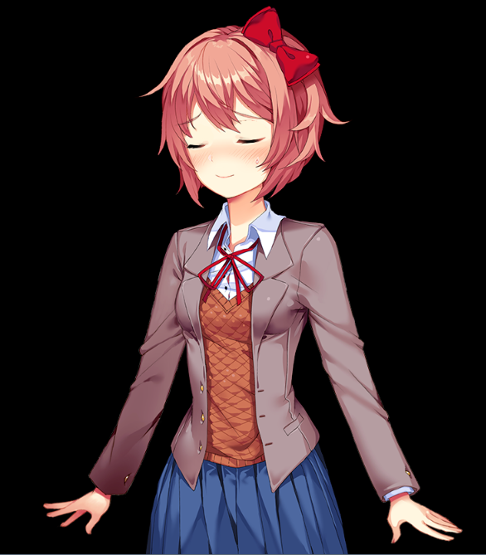 | Base DDLC:  This image doesn’t exist in base DDLC. Another round of image editing and making a new definition!
Posetool:
“show sayori u111392”
(Make sure to run the perl script after putting the tag in your script.)
layeredimage:
“show sayori ce blaw”

So, with the MPT, we’re starting to get the idea here - we can close the eyes with “ce” and we can close the mouth with “cm”. How do we open them back up? Simple - with “oe” and “om”:

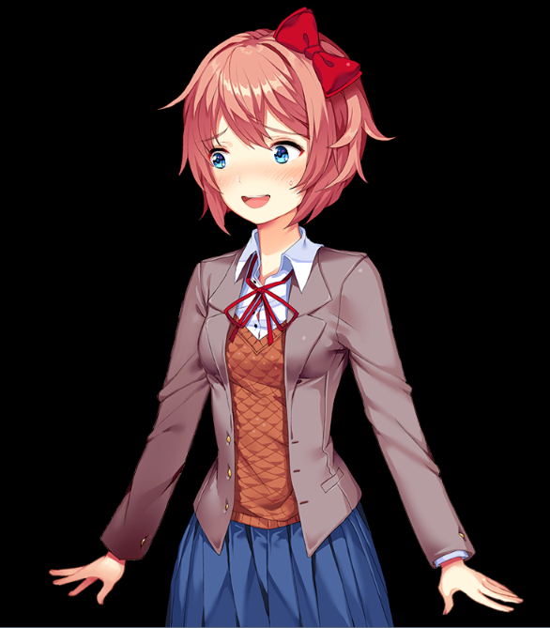 | Base DDLC:  This image doesn’t exist in base DDLC. Another round of image editing and making a new definition!
Posetool:
“show sayori u112322”
(Make sure to run the perl script after putting the tag in your script.)
layeredimage:
“show sayori om oe”
(To be fair, these are no longer the same eyes as from before, but that’s because these eyes are the actual automatic eyes for this mood. If you wanted to keep using the same open eyes as from before, you would continue to use “e1b”.)

Okay, that’s pretty simple, but you might already be thinking of a problem with this - those “oe”, “om”, “ce”, and “cm” tags are pretty short and easy to remember, but those specific mouths and eyes are what they show? What if I want a different mouth or eyes or something - those are obviously going to be something weird and less intuitive because those tags are already taken up, right?

Nope! This is where the huge advantage of this system’s “moods” comes into play - remember when we first showed this image, we showed Sayori with the mood tag “nerv”? That stands for the mood “nervous” - and every mood in this package has defaults that change what automatic tags do for that specific mood. Remember how the tags being applied to the character only change when we tell them to? Well, if we change the mood, it changes what the definitions for any automatic tags present are. Lets see that in action.

Our script now needs her to have a neutral expression on her face, but she’s still blushing. We’re not going to add or remove any tags other than her mood for this next example, but keep in mind that she still has the automatic tags “om” and “oe” applied to her right now:

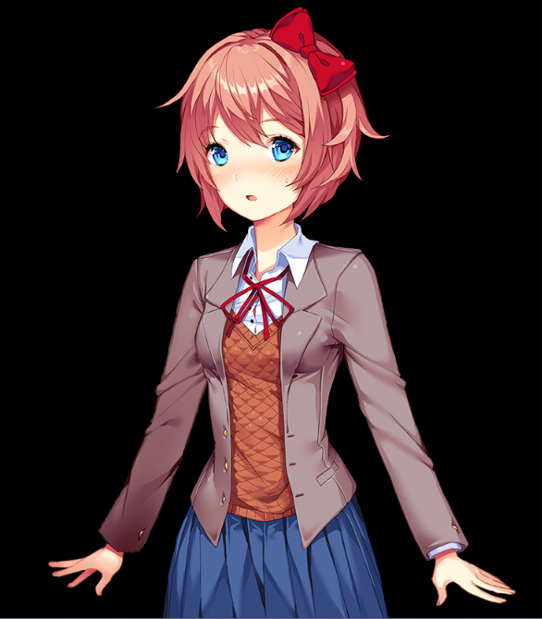 | Base DDLC:  This image doesn’t exist in base DDLC. Another round of image editing and making a new definition! Once again, there’s an expression that almost is the same - 1c - but it doesn’t have a blush on it.
Posetool:
This one’s not quite applicable, since this mouth does not exist in the posetool, but in fairness it’s not too difficult to add an asset to either it or the MPT. It’s the same format as usual, though:
“show sayori u11#311”
(Make sure to run the perl script after putting the tag in your script.)
layeredimage:
“show sayori neut”

Since Sayori’s mood has changed, the definitions for what “oe” and “om” are have changed too - as well as the definitions for “cm”, “ce”, and “brow” (did you notice her eyebrows change? That’s part of the mood, too!). So no matter what mood you have displayed the automatic tags “om,” “cm,” “oe,” “ce,” and “brow” will always show the appropriate version of the open/closed mouth/eyes and eyebrows if you tell it to do so. In fact, it goes even further than that, in that all poses and moods have defaults even if you don’t give them anything at all for a particular part of the image.

We’re going to pretend that we start fresh with Sayori here to demonstrate this - we’ve either used the function that refreshes a character’s tags (Which intentionally drops everything but the pose tag off the character - more on that later), or we’ve done something like hidden Sayori and then have shown her on-screen again. Here’s the bare minimum to show a sprite with MPT:

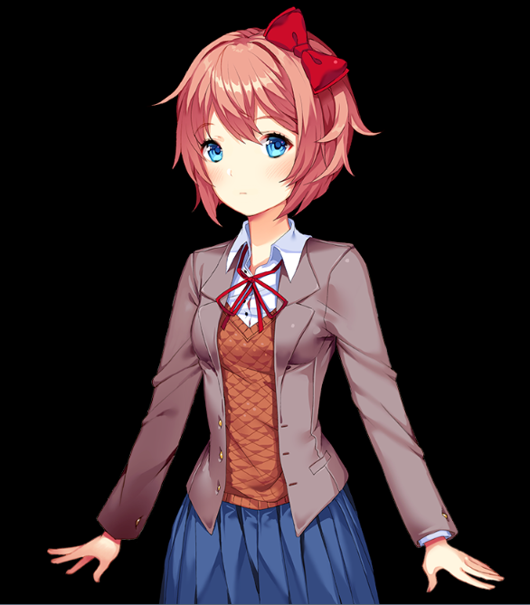 | Base DDLC:  This image doesn’t exist in base DDLC. Another round of image editing and making a new definition! 1b is the closest you get, but the mouth is different.
Posetool:
“show sayori u11a111”
(Make sure to run the perl script after putting the tag in your script.)
layeredimage:
“show sayori turned”

If you forget to put something for any single spot into either of the other two tags’ systems, then you won’t show anything at all (unless you’re in the SDK, in which case you’ll see the placeholder “missing image” sprite that lets you know you screwed up). The MPT, however, intentionally has defaults for each tag in a pose, so that if you don’t want or need to specify a tag, you’re covered; the only thing you’re required to give it is the pose tag specifically when you first show the character. That’s what “turned” means here - for Sayori (and Natsuki and Yuri), “turned” are their standard body positions in the MPT, while Monika’s standard is instead “forward”.

Basically, every time a sprite in the MPT is shown, everything that’s required for the character - the mood, the outfit, the arms, the mouth, the nose (blush), the eyes, and the eyebrows - either has an explicit tag given to it by the user, or it doesn’t see one given to it and thus shows the default for that; there’s no “Whoops, I forgot to put that part in, so everything has broken.” The whole point of the system is to make it quicker and easier for you - the user - to just get on with the job of posing everything you want, and skimming over whatever isn’t important to you as you go along to save time.

All of the following attributes have defaults on each character if the sprite doesn’t currently have a tag defining it:

- The character’s outfit (Defaults to “uniform”.)
- The character’s mood (Defaults to “neut” for “neutral”.)
- The character’s arms (Default to “rdown” and “ldown” for their respective arms.)
- The character’s mouth (Defaults to “cm”, for “closed mouth”, which is an automatic tag that changes based on mood.)
- The character’s nose/blush (Defaults to “nobl”, for “no blush”, which intentionally does not change based on mood.)
- The character’s eyes (Defaults to “oe”, for “open eyes”, which is an automatic tag that changes based on mood.)
- The character’s eyebrows (Defaults to “brow”, which is an automatic tag that changes based on mood..)

Each of these attributes can only have one tag in place at a time - if a sprite is passed a tag for an attribute that it already possesses, then the new tag overwrites the old tag. There’s no worry about tags somehow clashing with each other like this, or needing to remember what tags are already shown on the character if you don’t want to (The one exception being if you make the mistake of passing two tags for the same attribute to a sprite on the same line; this will throw an error in renpy.).

In addition to the defaults tied to moods, every attribute has separate tags for when you don’t want to use the default - like when you need a very specific face for something, but there isn’t an existing mood that works exactly for what you need. Let's say you have shown Sayori with a particular mood - she needs to be shocked at something, so you show her as such (We’re assuming that she hasn’t been shown on screen before, so we’re once again starting with the pose tag):

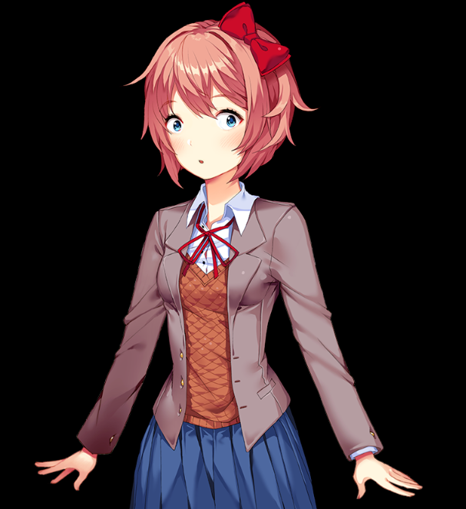 | Base DDLC:  This image doesn’t exist in base DDLC. Another round of image editing and making a new definition!
Posetool:
This one’s not quite applicable, since these eyes do not exist in the posetool, but in fairness it’s not too difficult to add an asset to either it or the MPT. It’s the same format as usual, though:
“show sayori u11####”
(Make sure to run the perl script after putting the tag in your script.)
layeredimage:
“show sayori turned shoc”

Okay, good - but, on the next line, you need her to be happy at the thing she’s shocked by, but still a bit surprised. The “shocked” mood’s open mouth isn’t really right for your use:

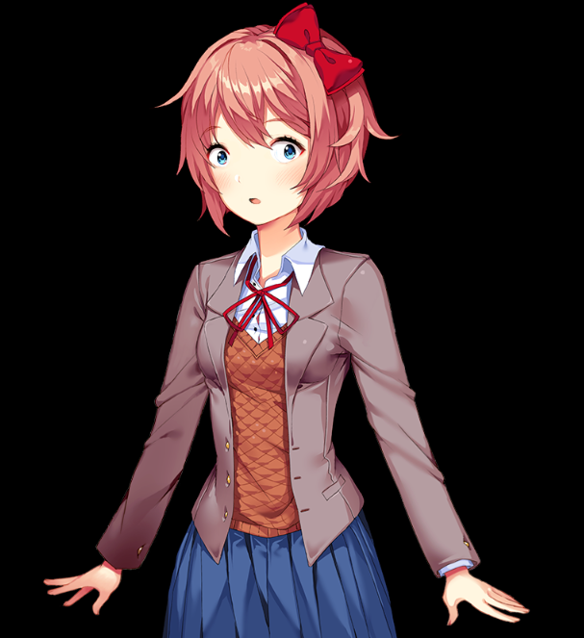 | Base DDLC:  This image doesn’t exist in base DDLC. Another round of image editing and making a new definition!
Posetool:
This one’s not quite applicable, since these eyes do not exist in the posetool, but in fairness it’s not too difficult to add an asset to either it or the MPT. It’s the same format as usual, though:
“show sayori u11####”
(Make sure to run the perl script after putting the tag in your script.)
layeredimage:
“show sayori om”

This is where being able to specify a particular component comes into play; you need her to have an open happy mouth as she talks about whatever’s going on - also, you decide that she should really have the awkward sweat drop too, so lets add that in too:

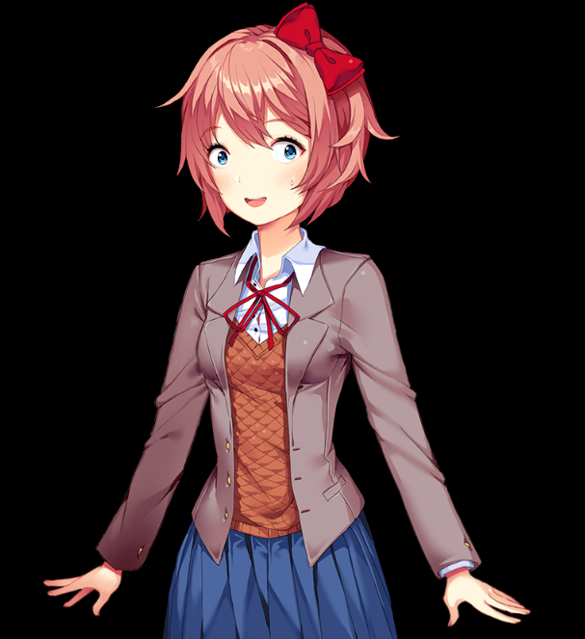 | Base DDLC:  This image doesn’t exist in base DDLC. Another round of image editing and making a new definition!
Posetool:
This one’s not quite applicable, since these eyes do not exist in the posetool, but in fairness it’s not too difficult to add an asset to either it or the MPT. It’s the same format as usual, though:
“show sayori u11####”
(Make sure to run the perl script after putting the tag in your script.)
layeredimage:
“show sayori mb awkw”

“mb” is not a default, it’s that specific open mouth - no matter what mood is in play, passing “mb” to Sayori will get that mouth, and no other one. Every component of the face has this same system - you can always decide on a specific mouth/nose/eye/eyebrow graphic, no matter what else is going on with your image. (The sole exception being certain eyebrows have issues with certain Yuri eyes, and thus are coded in not to display with those eyes.)

Now, the next line for Sayori just happens to have a whole lot going on. You eventually decide to do the following:

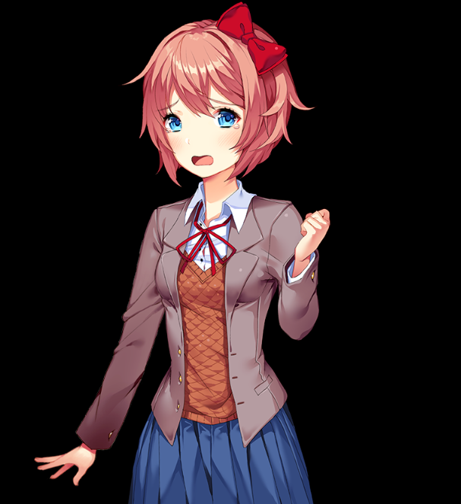 | Base DDLC:  This image doesn’t exist in base DDLC. Another round of image editing and making a new definition!
Posetool:
It’s the same format as usual:
“show sayori u12####”
(Make sure to run the perl script after putting the tag in your script.)
layeredimage:
“show sayori rup -awkw -mb cry oe”

There’s a lot to unpack here. Let's go through this one thing at a time:

First off - take a look at the order I gave those tags to Sayori. It’s...pretty strange, isn’t it? Can you work why they’re in that order, and what the logic is behind it?

The answer is that there isn’t any! The MPT doesn’t care in the slightest about the order of attribute tags for a pose - each of these statements would result in exactly the same image as the picture above, and are all equally valid:

- “show sayori rup -awkw -mb cry oe”
- “show sayori -mb cry -awkw oe rup”
- “show sayori cry rup -mb oe -awkw”
- “show sayori rup cry -awkw oe -mb”
- “show sayori oe -mb rup -awkw cry”
- (etc, etc)

This is another huge advantage the MPT has over the pose tool in terms of speed and usability; the pose tool requires both that you feed it a value for each and every spot in the tag - which is particularly draining when you’re typing out the same tag over and over except for one change in the tag - as well as also requiring that you get the order right each and every time. If you accidentally transpose two of the numbers without realizing it, you will end up with a tag that looks like a normal, “correct” tag at a glance - and, worse, remember that you won’t realize this mistake until after you’ve run the perl script and taken a look at it in action! Guess who’s fixing the problem and running the script again to check that it’s been fixed...

The MPT, however, just doesn’t care - throw the tags in whatever order you think of them! It’s all fine.

There is one possible exception to this, though as of this writing the exact cause is still being determined. The leading theory is that this is an issue present in earlier versions of Renpy 7.x, but does not seem to apply when using the current (as of this writing) version of Renpy, 7.3.5. Test this caveat yourself, and if the following doesn’t seem to apply to you, then you can safely ignore it:

The only known exception to the tag not mattering is when you need to show a character in a particular pose - such as when they first come on screen with a new “show” statement. It’s possible that Renpy will misinterpret that tag as an attribute, and not assign it as a pose correctly; this will result in your sprite incorrectly displaying. In that case, the only thing you need to make sure you get the order right for is that the pose itself needs to be the first thing in the list:

- “show sayori turned om ce happ b1a” is a valid image.
- “show sayori om ce happ turned b1a” is not a valid image, and will display the “missing graphic” sprite (or not show anything in a finalized build) if you try it.

The next thing - notice some of the tags have a hyphen in front of them? Specifically “-awkw” and “-mb”? The hyphen there basically means “remove this tag from the sprite” - so there is no longer the “mb” or “awkw” tags applied to the sprite. As a result, both of those attributes - the mouth and the nose/blush - return to their defaults like normal. The mouth specifically defaults to the open mouth for her “cry” mood, which is that large open mouth like you see there, while the nose/blush defaults to just her normal skin tone.

Finally, notice that I also passed it the “oe” tag...except that her eyes were already open. If you ever pass a tag that happens to be exactly the same as a default that’s already there...then, well, it’s okay! It won’t somehow break something, so you don’t have to worry about if you give it “too many tags” or something like that, so long as you always follow the rule not to give two tags for the same attribute at the same time.

Before you ask, giving two tags only applies if you’re giving it the same tags that are supposed to stay on the character - if you’re removing a tag for an attribute, that doesn’t count. So, if you decided to now close her eyes like so:

“show sayori -oe ce”

...Renpy won’t have any problem actually doing that for you. It’s not necessary to type that since simply giving it the “ce” tag will automatically overwrite the existing “oe” tag, but it won’t break anything to do so.

Okay, so! I know that was a lot to get through, but now that you’ve gotten through it, you have 95% of the knowledge needed to work with the system and just be off and running! The other subsections here go into a bit more minute detail about how things work and interact with each other. Feel free to skip them for the moment - you can come back and read them later.

2B - Refreshing a Sprite:
If you’re anything like me and how I use the MPT, you’ll be throwing tags at sprites left and right to do this thing or that thing constantly with characters and their expressions (I do this so often, in fact, that it’s what led me to literally make an entirely new posing system in the first place…). Sometimes, though, I want to just return most (or all) tags on a sprite to their defaults and start from fresh with the tags that are being applied to the sprite. This isn’t strictly necessary to do - since you can always just overwrite a tag for an attribute with an appropriate tag instead - but if you want to drop all tags off a sprite and return to all the default values for it with a relatively short command, there’s a series of functions designed specifically for that:

- “$ mref()” will drop all tags off Monika’s sprite, if it’s both on-screen and actually using an MPT pose.
- “$ sref()” will do the same for Sayori.
- “$ nref()” will do the same for Natsuki.
- “$ yref()” will do the same for Yuri.

If you use any of these lines in your script, then it will return the sprite to all default attributes for whatever pose it is in at the time; this effectively removes all tags (other than their pose) from the sprite, which results in the sprite assuming all defaults. Without getting into it too much...this is basically what’s happening:

- You’re showing a sprite with any number of tags currently applied to them. Example: Yuri is shown on screen, and is currently:
  - “yuri turned angr b2a om ce rup lup awkw”
- You invoke her refresh function:
  - “$ yref()”
- After the line that the function runs on, Yuri now has the following tags applied:
  - “yuri turned”
- Because there are no longer tags explicitly in place for any of her attributes, they all default to their default values, even if they’re not being shown. In this specific instance, it’s the equivalent of if you had decided to explicitly show Yuri as:
  - “yuri turned neut ldown rdown cm nobl oe brow”

From this point, you could immediately throw new tags onto her if you desired. Literally the next line after “$ yref()” could then be “show yuri happ om”, and the end result would be an instant and seamless transition from the first sprite shown (“yuri turned angr b2a om ce rup lup awkw”) to the new sprite shown (“yuri happ om”).

Note that the refresh functions will reset their clothing back to “uniform” - so if you’re using a casual outfit, you’ll need to put it back on them after invoking the command. (Later updates may account for this and allow the function to leave that attribute alone.)

One final note: If you hide an MPT sprite at any time, all tags are dropped off it; they will not persist and show up again the next time you show the sprite.

SECTION 3 - CHEAT SHEETS AND CHARTS
(Click me to return to the table of contents)

So you want to just jump into using this stuff? Okay - follow the charts below and you’ll be fine for the most part.

First off - in the weird situation where you’ve somehow gotten to this document without the links to the individual characters’ cheat sheets, here they are again:

- Monika
- Sayori
- Natsuki
- Yuri

Table A is just the generic form of how the attribute tags can be dropped into either a Renpy “show” statement or in-line with a line of dialogue from a character:

TABLE A - Mood Posing Tool Usage Chart (Generic Form)
Normal Renpy | Layeredimage Specific Tags |  |  |  |  |  |  |  |  |  | Normal Renpy
Line Start  (Standard Renpy Language) | Pose Tag*  (Only if required) | Attribute Tags (All are optional, can be used in any order so long as they’re between “Line Start”/“Line End”)  (Only one tag per attribute; using multiple tags for the same attribute in one statement will produce a Renpy error)  (Not all tags are available for all poses; reference individual character cheat sheets for further details) |  |  |  |  |  |  |  |  | Line End  (Standard Renpy Language)
Line Start  (Standard Renpy Language) | Pose Tag*  (Only if required) | Head  (Natsuki only) | Clothing | Mood | Right Arm | Left Arm | Mouth | Blush | Eyes | Eyebrows | Line End  (Standard Renpy Language)
show [character] | [pose] | [head] | [clothing] | [mood] | [right arm] | [left arm] | [mouth] | [blush] | [eyes] | [eyebrows] | [end of “show” statement]
[character letter tag for dialogue] |  |  |  |  |  |  |  |  |  |  | “[Dialogue]”
* There is currently an unexplained issue where not writing out the [pose] tag first might result in the sprite displaying properly. If you encounter unexplained problems with sprites not displaying properly despite all tags and the pose being written correctly, but the pose tag is not written out before other tags, try writing the pose tag before all other attribute tags and see if that solves the issue.

Table B is broadly most of the available tags for each character in each pose, as well as outlining which tags are default values, which tags are automatically altered by mood, and what specific shorthand tags exist.

In all cases, please refer to each character’s individual cheat sheet for more comprehensive documentation of that character, as well as visual examples of the available attributes.

Note that as of this writing, the current version (v1.0) does not yet include all moods/assets/etc for each special pose; future updates are intended to build upon this and rectify this.

TABLE B - MPT Pose/Attribute Tag Cheat Sheets
“Standard” Pose Tags
(Default values are shown in bold text, automatic mood tags are shown in underlined text, fixed tags are shown in italicized text.)
Attributes that have automatic tags dependent on the “mood” attribute are marked with “(Mood)” underneath them.
(For specific fixed tags, reference the individual character’s guide for further details)
Character | Pose Tag | Attribute Tags (All are optional, and can be used in any order)  (Only one tag per attribute; using multiple tags for the same attribute in one statement will produce a Renpy error)  (Not all tags are available for all poses; reference individual character cheat sheets for further details)
Character | Pose Tag | Head* | Clothing | Mood | Right Arm | Left Arm | Mouth  (Mood) | Blush | Eyes  (Mood) | Eyebrows  (Mood)
monika | forward | N/A | uniform  casual | neut  angr  anno  cry  curi  dist  doub  flus  happ  laug  lsur  nerv  pani  pout  sad  sedu  shoc  vang  vsur  worr  yand | rdown  rhip | ldown  lpoint | cm  om  mX | nobl  awkw  blus  blaw  n# | oe  ce  e#X | brow  b#X
sayori | turned | N/A | uniform  casual |  | rdown  rup | ldown  lup
natsuki | turned | ff*  fs*  fta* | uniform  casual |  | rdown  rhip | ldown  lhip  lpoint
yuri | turned | N/A | uniform  casual |  | rdown  rup  rcut | ldown  lup
“Special” Pose* Tags
(Default values are shown in bold text, automatic mood tags are shown in underlined text, fixed tags are shown in italicized text.)
Attributes that have automatic tags dependent on the “mood” attribute are marked with “(Mood)” underneath them.
(For specific fixed tags, reference the individual character’s guide for further details)
Character | Pose Tag | Attribute Tags (All are optional, and can be used in any order)  (Only one tag per attribute; using multiple tags for the same attribute in one statement will produce a Renpy error)  (Not all tags are available for all poses; reference individual character cheat sheets for further details)
Character | Pose Tag | Head* | Clothing | Mood* |  |  | Mouth  (Mood) | Blush | Eyes  (Mood) | Eyebrows  (Mood)
monika | lean | N/A | uniform  casual | happ  angr  anno  neut |  |  | cm  om  m# | nobl  awkw  blus  blaw  bful  n# | oe  ce  e# | brow  b#
sayori | tap | N/A | uniform  casual | nerv  angr  dist  neut  pout
natsuki | cross*  (See note) | ff*  fs*  fta* | uniform  casual | neut  cry  sad
yuri | shy | N/A | uniform  casual | neut  angr  happ  sad
* Natsuki’s expressions are dependent on which head is in use, not which pose is in use. When showing her with her “cross” pose, her head - whichever one is in use - is merely transposed to fit onto her body, without any other special changes, and neither the left arm nor the right arm attributes have any value for that graphic. Her default forward face (“ff”) has the usual suite of mood and mouth/nose/eye/eyebrow tags associated with it but her sad face (“fs”) has less flexibility due to the amount of available assets, and her turned away face (“fta”) has no facial attributes whatsoever - there’s only the one graphic available for it at this time. Values for Natsuki’s mood on the above “special” poses table specifically refer to moods available for her sad face (“fs”). Also of note is that Natsuki will “technically” display moods other than those listed above, but trying to show any moods with her “fs” face other than the ones listed above will result in a blank face.

Utility Functions:
- Refresh Functions (These will drop all tags off a sprite and return them to their defaults):
  - Monika: “$ mref()”
  - Sayori: “$ sref()”
  - Natsuki: “$ nref()”
  - Yuri: “$ yref()”

Further utility functions are planned, but not yet implemented in the current (v1.0) release.

SECTION 4 - PROGRAMMING, LOGIC, AND ADDING YOUR OWN ASSETS
(Click me to return to the table of contents)

Okay - so here’s where we get into more specific information about how this has been programmed. If you read through this section, you’ll get both a better understanding of how the tool works, as well as guidance on how to add your own things into your copy of the tool - new art assets, new moods, even going so far as to letting you implement even more complicated logic if you want to try and make even more automatic tags and controls!

4A - Layeredimages, and their implementation in the MPT:

Every sprite in the MPT is based on a new feature of Renpy 7.x - “layeredimage”. Layeredimage is a new way to define an image by giving a particular named sprite a pose, attributes underneath that pose, art assets that are controlled by those attributes, and logic to further control attributes if you so desire.

Rather than try to reinvent the wheel and explain how layeredimages themselves work, I’ll instead point you to the official Renpy documentation for the layeredimage feature: click here to read said documentation. Go read that to get the basic idea behind layeredimages in general, but for this readme we’re going to focus on the specific implementation of these sprites and their automatic control in the MPT - the mood system.

This is fairly straightforward, it just requires foresight and clearly laying out logic so that sprites correctly display what they have to when they have to. We’ll take a look at Monika’s programming for her pose “forward”:

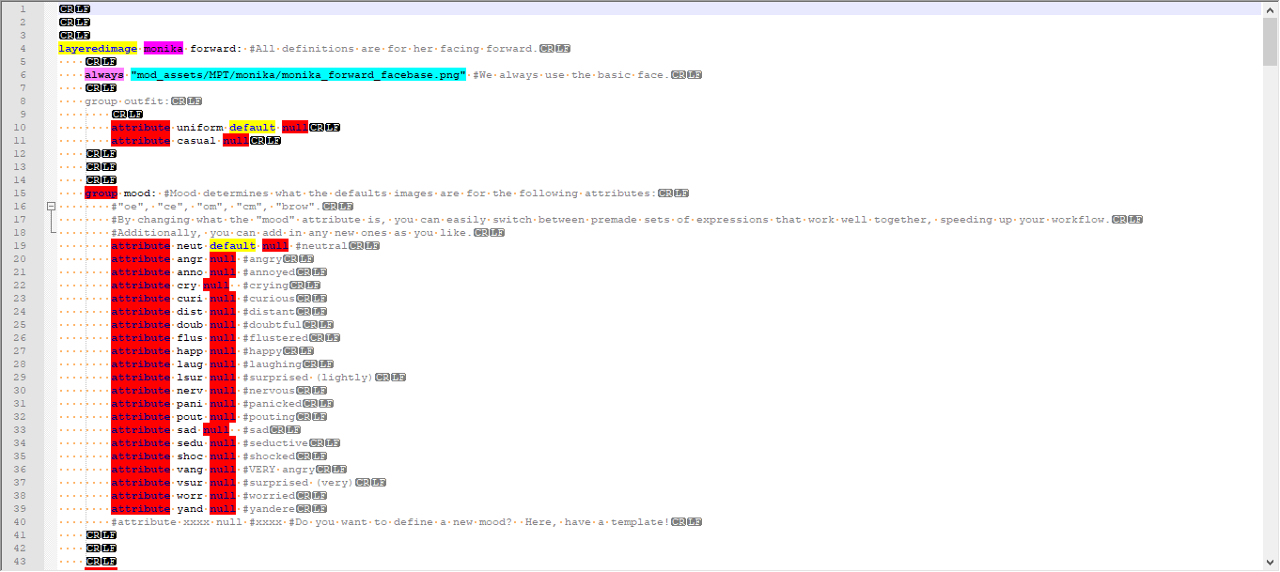

Here’s what’s important to note here - specifically for her “mood” attributes, since that’s what we’re interested in:
- Each of the mood attributes is a “null” attribute - this is important, since these attributes just control logic for the rest of the sprite, and do not have their own graphics associated with them directly. If we specified an attribute like this for logical control and without giving it either an image to display or the “null” keyword, Renpy would error out. “Null” basically just tells Renpy not to bother searching for an image for that attribute.
- Our default attribute for the “mood” group is “neut” - for neutral. If we didn’t have at least one mood set as the default, it would be possible to render the sprite without a mood - which would mean that no eyes/nose/mouth would render. This is obviously a problem.
- This isn’t obvious by just this code itself, but per the comment the moods specifically only control what the attributes “cm,” “om,” “ce,” “oe,” and “brow” are at any given time. This is the functionality that allows the user to specify the mood they want/need, and then just have the ability to just use those short automatic tags to do the most common things they would want or need for a character.

For every attribute group that has automatic tags (i.e. logically controlled by what mood is in use), there’s some variation on code that checks for all the attributes necessary to display that specific sprite:

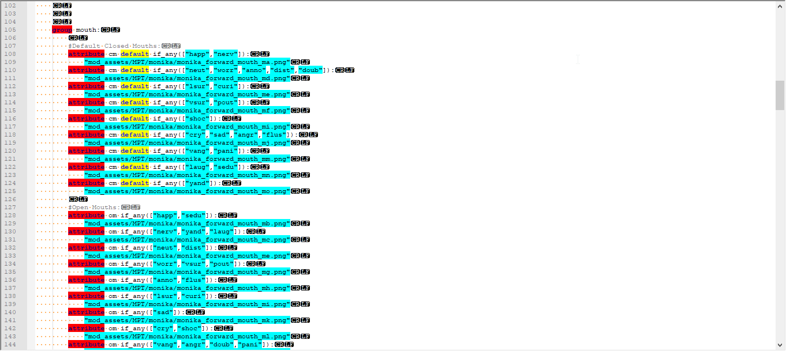

For Monika and her forward sprite, the logic is pretty simple; all it needs to do is have the following:
- It needs to have the name of the attribute tag (obviously)
- It needs to have an image to display (obviously)
- And it needs to have the actual logic check applied; to cut down on the amount of lines necessary and to organize/group the code better, every individual image used for an automatic attribute tag has an “if_any” logic check on it, and each mood that uses that specific image for that automatic tag is listed inside that “if_any” check. In our example above, quite a lot of open mouths for Monika and her moods are her “monika_forward_mouth_md.png” image - “neut”,”worr”,”anno”,”dist”,”doub”.

In addition, every attribute that needs to be displayed has at least one of said attributes defined as a default; for autotags, this is no different...and, specifically, each variant on an autotag that’s assumed to be a default has the “default” line in it. Hence why every single “cm” attribute - the default mouth attribute when one isn’t assigned - has “default” enabled for it. With the mood logic correctly in place, only one of those attributes can ever be both “the default” and “actually visible” at any time.

4B - Adding new moods and assets:

Adding new moods is pretty simple: just add a new attribute into your poses’ “mood” group, and remember to give it the keyword “null”. Then, for each attribute you want the mood to have control over, ensure that it is shown in the logic controlling the display of that attribute and the specific image. If you wish to follow the given system in the basic mood posing tool, then you need to make sure your mood shows up in the logic for all of the following autotags:

- “cm”, as a “default”
- “om”
- “ce”
- “oe”, as a “default”
- “brow”, as a “default”

Adding new images is also fairly straightforward; there are a lot of other ways to define images in Renpy - and this guide will not be covering them - but so long as it’s either an image defined with the attribute in the layeredimage definition or is a named image defined elsewhere in your project in general, you can use an attribute with it. If the image in question is something you would like to be controlled by a mood, just ensure that it also gains the same logical checks to ensure it’s only visible when intended to be. If you want to add in new assets the same way that layeredimage defines them, I recommend you read up on the official Renpy documentation for more information.

For this guide, I’ll include a quick example of just that. Say you want to have a new mood for Yuri in her “turned” pose, and you’ve settled upon the following as what you want her face to look like for this new mood:

“e2d mm b1f”  (open eyes, closed mouth, and special brows for her open eyes) | “e4c mc b3a”  (closed eyes, open mouth, and special brows for her closed eyes)
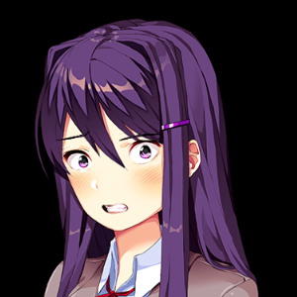 | 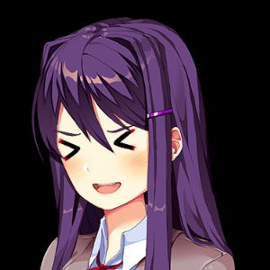

(Side note: I have no idea why you’ve decided on this being a mood, but I’m not here to judge…)

Anyway. First thing we do is add our mood’s keyword into her mood group - we’ll call it “example” just to keep things simple:

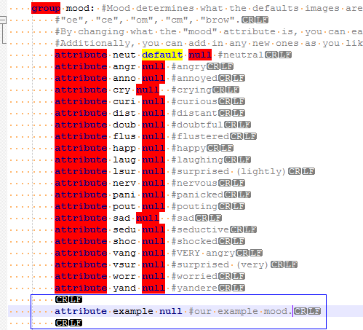

Now that we have that, next we move to every group that has an attribute we want to use with this mood:

- We have a set of open eyes, and a set of closed eyes.
- We have an open mouth, and a closed mouth.
- We’ve also decided to be fancy, and use eyebrows that change depending on whether the eyes are open or not.

That’s 6 attributes we’ll have to associate with this mood. Let's start by scrolling down - first we come across all the other groups and attributes that make up Yuri, but are not a part of this mood’s attributes. After several of these groups, we come across the first relevant group - “mouth”:

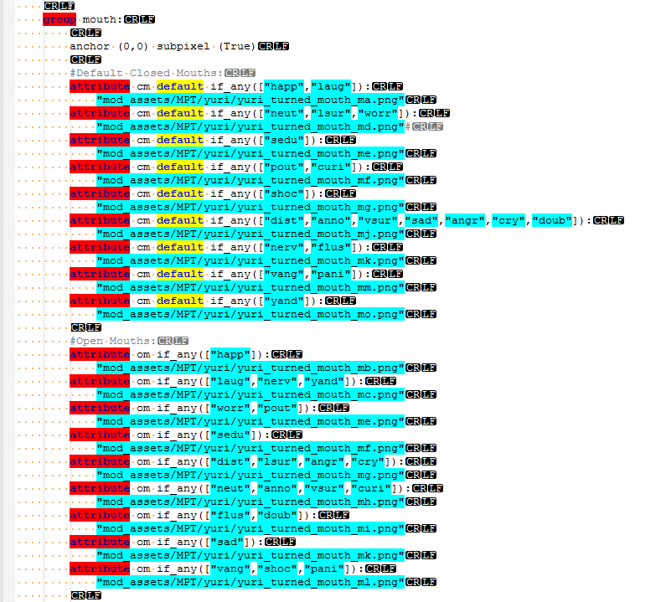

To follow the format already established, you then do the following:

- First, we check to see if “mm” - our closed mouth - is already used for a definition. It is:

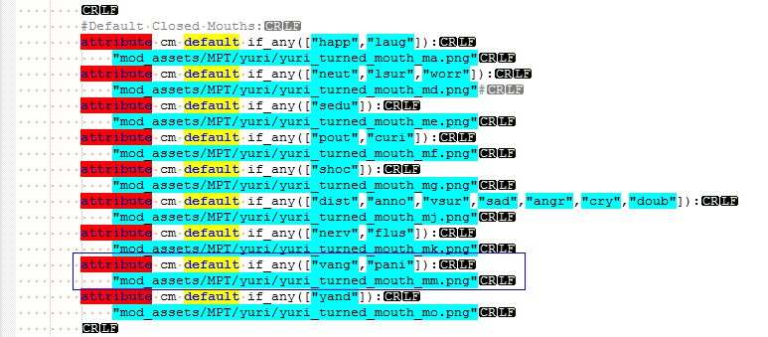

That makes this the easiest possible thing to add our mood to this mouth. All you do is add it into the “if_any” logic check on the line above:

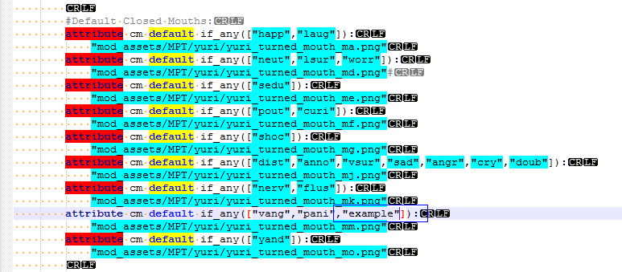

- Next, we go to the open mouths, and look to see if our open mouth “mc” is in use, just like how we did for our closed mouth. It is:

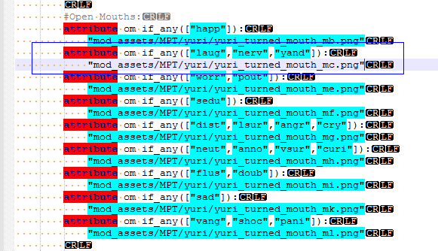

So we do the exact same thing as we did with the closed mouths, and add in our new mood:

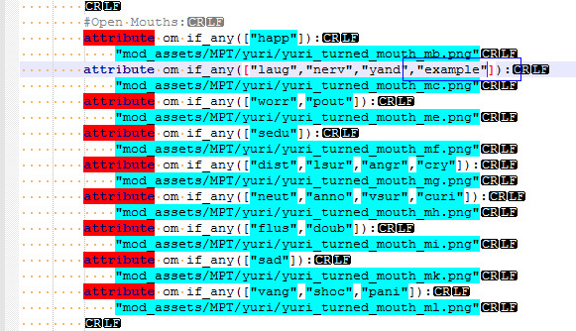

That does it for our mouths - now onto the next category.

- Next up are our eyes, which is the group right below the mouth category:

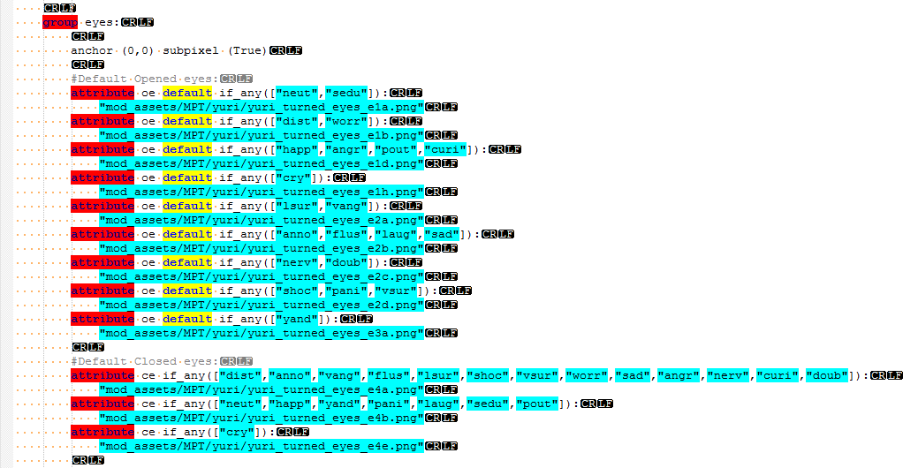

For the open eyes, it’s the same as it was with the mouths - we look to see if our tag “e2d” is already in use - which it is - and then add in our mood to the tag for it, like before:

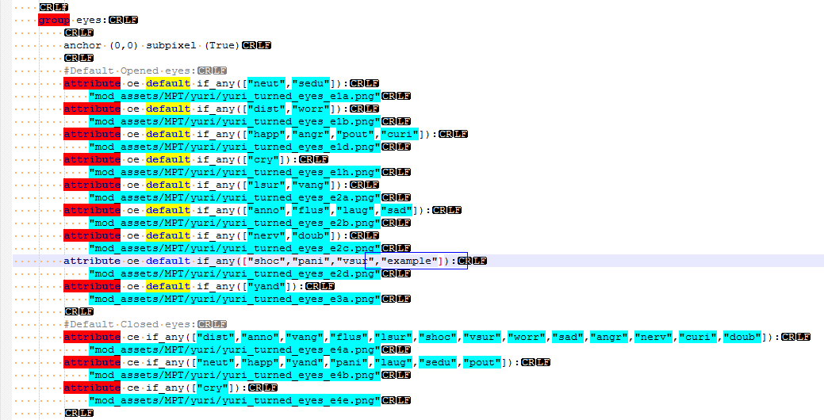

Now for the closed eyes - we check to see if our tag “e4c” is in use already. This time it isn’t, so we can’t just tack our mood onto an existing attribute - we need to make a new one:

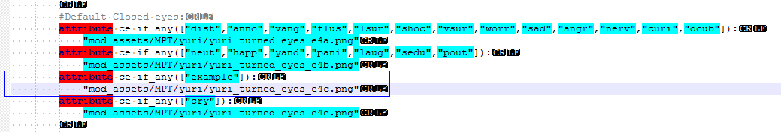

With that added in, we also have open and closed eyes defined for our mood. Just one last attribute to add!

- Now for the brows. Below our eye group is the eyebrow group:

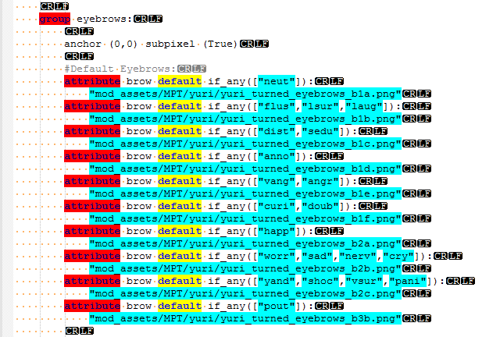

Under normal circumstances, adding our mood would be very similar to how we’ve done it before - either find an asset that’s already defined as a “brow” attribute, or make a new attribute using our preferred asset. This time, however, there’s a twist - we want the opened eyes to use one set of eyebrows, but the closed eyes to use a different set of eyebrows. Some of the other characters already do this with their moods - Natsuki is a good example of this - but Yuri doesn’t currently have anything defined like that. Well, our example is going to fix that! To do this, we’ll technically have to define this attribute twice - once for when the eyes are open, and another time for when the eyes are closed. To keep this simple, I’m intentionally going to put the new attribute definitions spaced out below our current block of “brow” attributes:

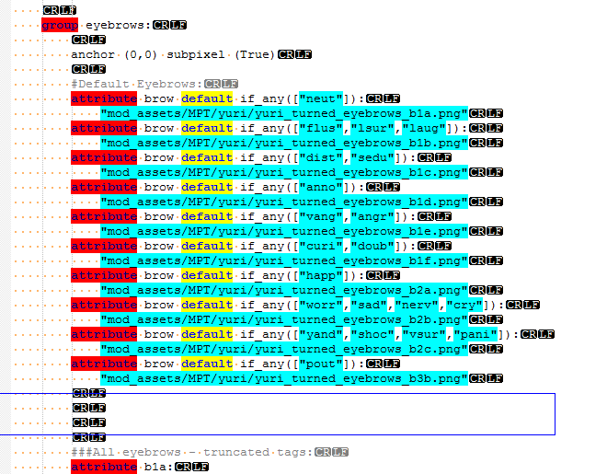

The attributes will be very similar to what already exists, with one big exception on each one. We’ll get to that in a minute, but first we write out both of our brows we want to use like normal:

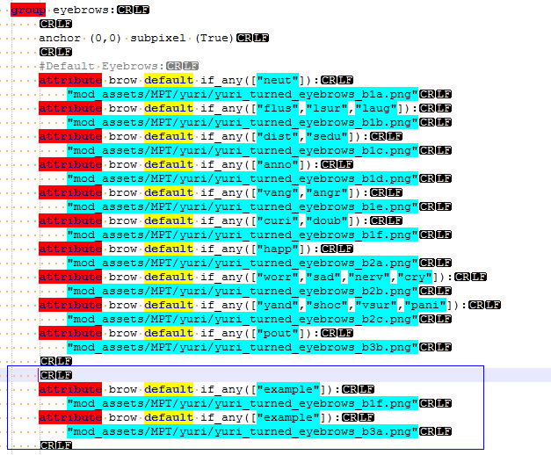

Now, if we were to stop right here and not continue any further with fixing our definition, what would happen is that these eyebrows would work like any of the normal eyebrow definitions when we showed Yuri with this new mood, “example” - except we don’t have any logic to control these eyebrows, other than just saying they should show up if the tag “example” is shown on Yuri. This wouldn’t work well, since what would happen is renpy would only show the “b3a” eyebrows - no matter if the eyes were open or not - since they’re the last item on the list. We need to add in a way to filter these eyebrows to only show the right one when they’re supposed to - and we can do that with the other available logic checks in the attributes: “if_all”, and “if_not”. We’ll only need to use one of these checks for this particular example, “if_all”:

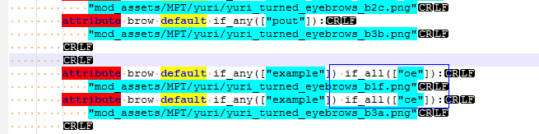

We’ve now defined both of our brows for this new mood! But what exactly is going on with these logic checks?

Well, I don’t want to go into a huge amount of detail - again, I’ll instead point you towards the official Renpy documentation about attributes - but, in short, attributes follow a few rules when it comes to their display logic:

- All of the logic that checks whether they should display or not has to return “True” for the attribute to be capable of being displayed. If anything returns “False”, then the attribute cannot be displayed.
- That logic is controlled by the following:
  - “If_any” is a list of strings, representing other tags on the image. It will return “True” if at least one string in the list is present on the image.
  - “If_all” is a list of strings, representing other tags on the image. It will return “True” if and only if every listed string is present on the image.
  - “If_not” is a list of strings, representing other tags on the image. It will return “True” if and only if none of the listed strings is present on the image.
- Those logic checks can be applied either to a group or to a specific attribute; this is helpful if you want to have an entire group have the same shared logic, and then apply different logic to each individual attribute.
  - As a user, I really want to point this particular wrinkle out, since it took me a long time to figure out that it was a thing. During that time I made a lot of mistakes with logic that didn’t seem to make sense, and I want to try and prevent anyone else from having this problem unexpectedly: You cannot use the same logic check tag for both a group and an attribute and expect them to combine their logical checks together. The attribute logic check tag will overwrite and ignore the group’s attribute logic check tag. If you give a group “if_not([“a”,”b”,”c”])” and then an attribute in that same group “if_not([“d”,”e”])”, they will not combine to make it so that the attribute will only display if none of the tags “a”, “b”, “c”, “d”, or “e” exist on the image; instead, only the attribute logic check will work, completely overwriting/ignoring the group logic check - and thus only “if_not([“d”,”e”])” will work. Trust me on this one...it took me far too long to figure it out.

So, with that out of the way - let's get back to our definitions. What we’ve done is pretty simple, then...we’ve just said that both “brow” tags can only display if our two conditions - the “if_any” for our mood, “example” and the “if_all” for either the open eye tag “oe” or the closed eye tag “ce” - are true. Since one can only be true if her eyes are open, and the other can only be true if her eyes are closed, they’ll never try to display at the same time, and will instead display alternately, depending on whether her eyes are open or not.

With the last block of code enacted, we’re actually done! Yuri now has a new mood, “example,” which now has all the relevant autotags associated with it. You can test it for yourself in the “looping black background” menu option:

One design decision I’ve made with the tool is that I intentionally omit the “blush” sprites from being controlled by the moods; this is a personal choice on my end. I feel that a character’s mood is more actively controlled by the character consciously, but whether a character is blushing or not is not consciously controlled by them, ergo why I’ve separated them out like that.

If this isn’t to your liking, it’s possible to add them back in to be controlled by moods; you’ll simply need to define the nose/blush graphics in largely the same manner as the other graphics are controlled. This includes:
- Giving the character a new autotag to define their nose/blush (I’d suggest something like “nose”, since that’s not used and is pretty straightforward).
- Giving the character a list of the defaults for what exactly your new autotag (“nose”) is, each one making sure to include the required logic to show that default only if a relevant mood is given (This being the “if_any([“mood”]) logic present in other autotag examples).
- Don’t forget that you’ll still have normal override control (“nobl”,”awkw”,”blus”) if you still want to display a particular blush with a mood, so long as you do not change that logic or those tags.

4C - Specific exceptions:

One final thing to touch on in this section are some of the exceptions and oddities in the code - the two biggest examples of such being Natsuki and Yuri and their logic, and a smaller general example with everyone’s eyebrow logic. In brief:

The smaller “eyebrow” thing refers to some specific code that’s in place to prevent certain eyebrows from being shown with incompatible eyes - most of the time, it’s due to eyebrows that can only be shown when characters’ eyes are closed, and most of them are the same tags for each character: “b3a”, “b3b”, and “b3c”. If you try to show one of these eyebrows and it just refuses to display, it’s probably hitting this logic. Look at each characters’ definitions file for further details.

Yuri has a few larger eyes which are larger (and differently shaped) from her other eyes - enough so that certain eyebrows cannot be shown at the same time as those eyes without them very obviously clipping over each other. For any moods of Yuris’ that invoke these yandere eyes, there is additional programming to ensure that only brows that will not clip can be displayed at the same time. You’ll know when this happens if you’re using any of those eyes and the brows you tried to use suddenly disappear, leaving Yuri browless.

Natsuki is - without a doubt - the most different code wise and logic wise from any of the other characters. The biggest problem with her is that she has an attribute that none of the other characters (currently) has, “head,” which controls which of the 3 basic heads she is displaying.

The reason for this is that unlike everyone else, her facial expressions and sprites are not determined by which pose she is using, but instead which head she’s using, since both poses can use the same heads. There’s two ways to address this problem:

- Treat the two bodies like separate poses...which results in literally doubling the amount of code for all her facial features, since the separate pose requires a transform to be applied to each and every facial attribute to work with it, or
- Tread the two bodies like individual attributes within one pose, and basically showing both versions of each attribute twice and directly adjacent to each other - one with the necessary transform, one without.

The code has been written and rewritten as both options during development (be glad you weren’t there…), and the current system is closer to the first option currently. To try and cut down on the amount of superfluous code that would have to be rewritten in the event of a change, Natsuki’s definitions have a second layer of in-between image definitions, which are then used across both poses. See her specific file for further information.

SECTION 5 - VERSION HISTORY AND ROADMAP
(Click me to return to the table of contents)

Future planned/potential features:
(Not all features may necessarily be implemented - we won’t know until we get around to trying if they will be/can be or not.)

- New art assets:
  - Equivalent moods across all poses for all characters; as of v1.0, the characters’ special poses do not have as many moods as their “normal” expressions. This is primarily due to a lack of art assets for these poses. Once these assets are acquired, the moods for these expressions will be expanded upon.
  - Further improvements and refinements to the existing art assets; Essentially to tweak the existing art assets and get them to blend with each other better.
  - Additional art assets in general; to allow for more variability. Things ranging from the small - new facial expressions - to bigger things, such as new outfits and characters.
    - An example of a new character: The Natsuki Dad sprite made by SovietSpartan.
- New coding and features:
  - “Side Eye” system; Much the same as the “oe” and “ce” system, a system wherein the user can easily/quickly change a sprite to look forward versus sideways. This requires further art assets to implement.
  - Autofocus; An updated version of the publically available “automatic focus” feature - where characters that are talking move to the “f” version of their screen position, and then drop back to the “t” version of their position when they finish.
  - Auto open/close; Character callbacks can streamline the process of controlling things like characters’ mouths being open/closed when necessary even further.
  - Added functionality with automatic changes; One thing I’d like to try and do is add in more variations with the brows between two things:
    - Eyes being opened/closed
    - Mouths being opened/closed
    - In addition to the above, I’d also like to add in another logic attribute that would allow the user to override automatic control of these differences; for example, if a mood has a different set of eyebrows for both open/closed mouths and open/closed eyes, but the user only wants the brows to change based on the mouth opening and closing but not the eyes opening and closing (or vice versa), then they’d input an attribute that would disable said changes - and at any time could re-enable said attribute.
  - Figuring out how the `auto` system works for classifying images - that would make it *very* easy for the end user to just add assets with the correct names into the folder and almost entirely avoid any further coding to use said assets.

Version/Change Log:
V1.0 - Initial Release:
- Original general release of the MPT!
V1.01 - Reorganization of functions:
- Changed the location of the “xref()” functions to be in the MPT folder itself, so it’s not accidentally lost when dropping the folder into your project.
- Any and all future functionality updates will be located here as well, so as not to accidentally leave them in the main /game/ directory.

SECTION 6 - ADDITIONAL LINKS
(Click me to return to the table of contents)

- Monika cheat sheet
- Sayori cheat sheet
- Natsuki cheat sheet
- Yuri cheat sheet

Renpy Layered Image Documentation: https://renpy.org/doc/html/layeredimage.html

SECTION 7 - CREDITS AND THANKS
(Click me to return to the table of contents)

Team Salvato - for, y’know, making DDLC in the first place and then being cool with people making mods for it.

Yagamirai - Art assets
Terra - Coding
MrGraves - Testing

Doki Doki Modding Club and staff - since having an actual community to make this for and get support from is rather important.

AgentGold and his posing tool - as much as I’ve ragged on it in this document, I’ve still done a whole lot of posing in it, and I might not have even made this tool in the first place if it didn’t exist to give me the idea in the first place.

